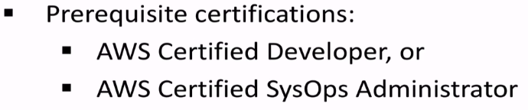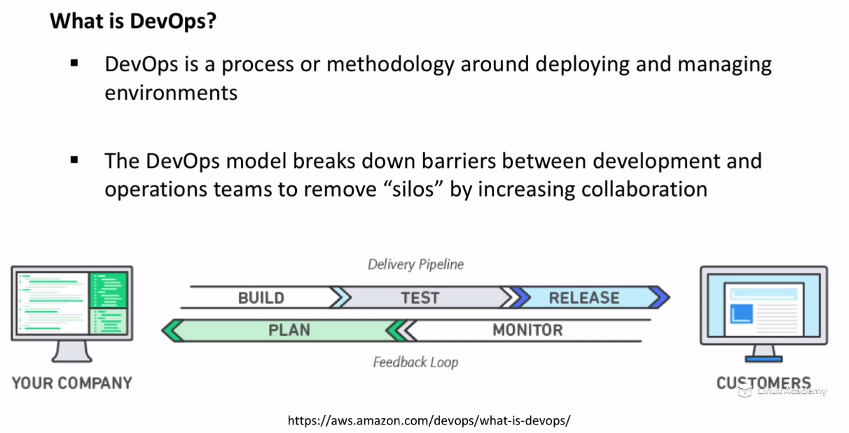

Devops is not a piece of s/w.. It’s a process or methodology (concepts) that helps to deliver APP/services faster than before.

We can use S/W to implement these process or concepts. So Devops is often associated with tools.

Remove Silos, Developers and Ops collaborate together for success of Org..We csan also integrate Quality assurance,security,AD team or any team that touches LIFE cycle of project..

In order to do this, need to see who works on what part of LIFE cycle.For EX: for Devt,testing,Deployment part of Life cycle:::Instead Devopers completely involve in these steps OPS team can also uinvolve in these…So we don’t get into scenario that everything works on Developers m/c and breaks in Production..And Ops left with CleaningUp mess in Prod..

So we eliminate that Silos and we encourage collaboration at every level.So we can have automation standards and steps to follow for high velocity Pipeline..

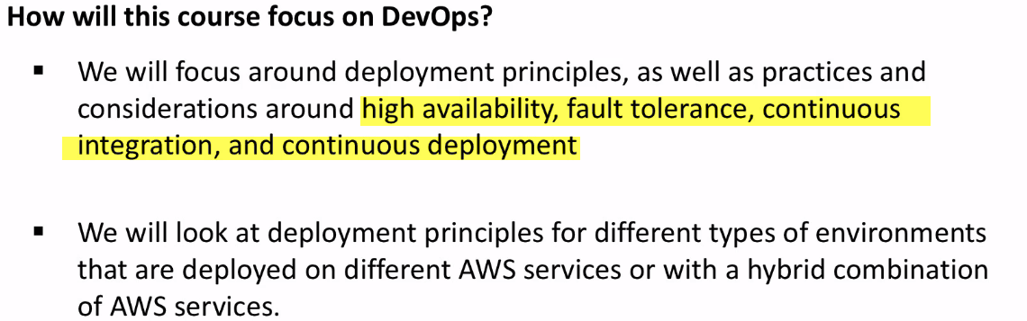

Elastic BeanStack

Cloud Formation

AutoScaling

OpsWorks

We don’t focus on CodeCommit, CodeDeploy.. 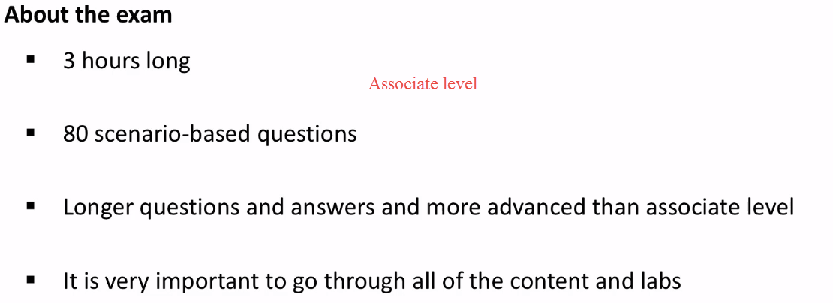35-291-4 - Types of Deployments

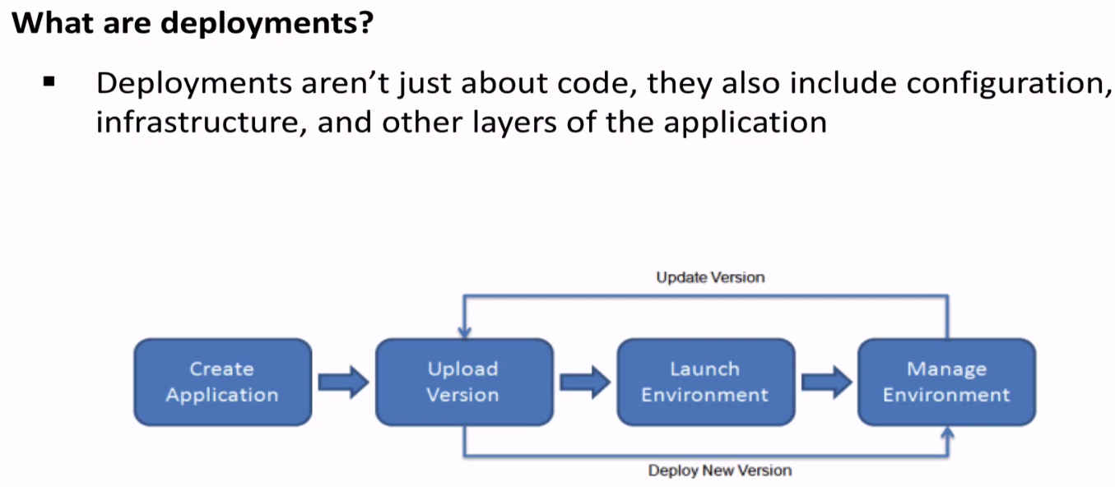

M4 small to large

Deploying Config. Using Chef

Deploying updates to existing ones, rather than launching new ones.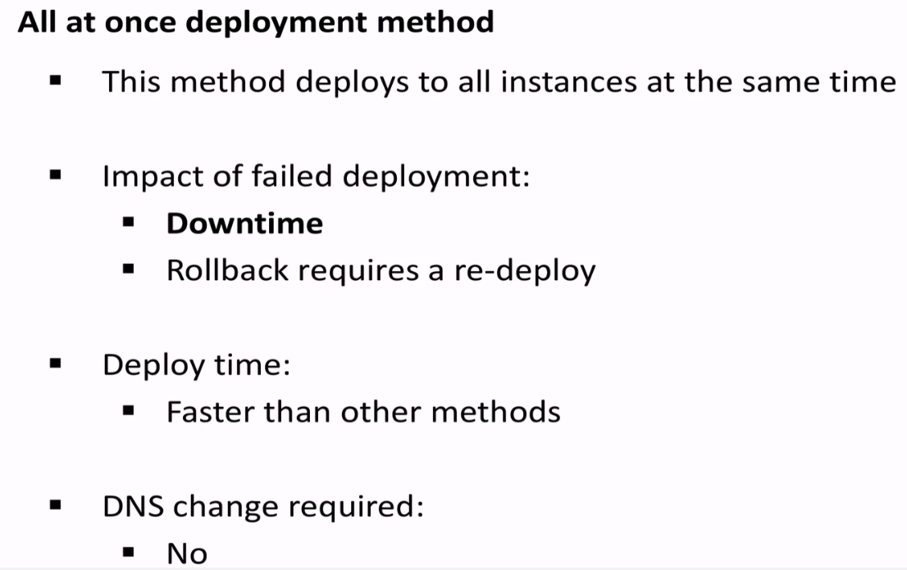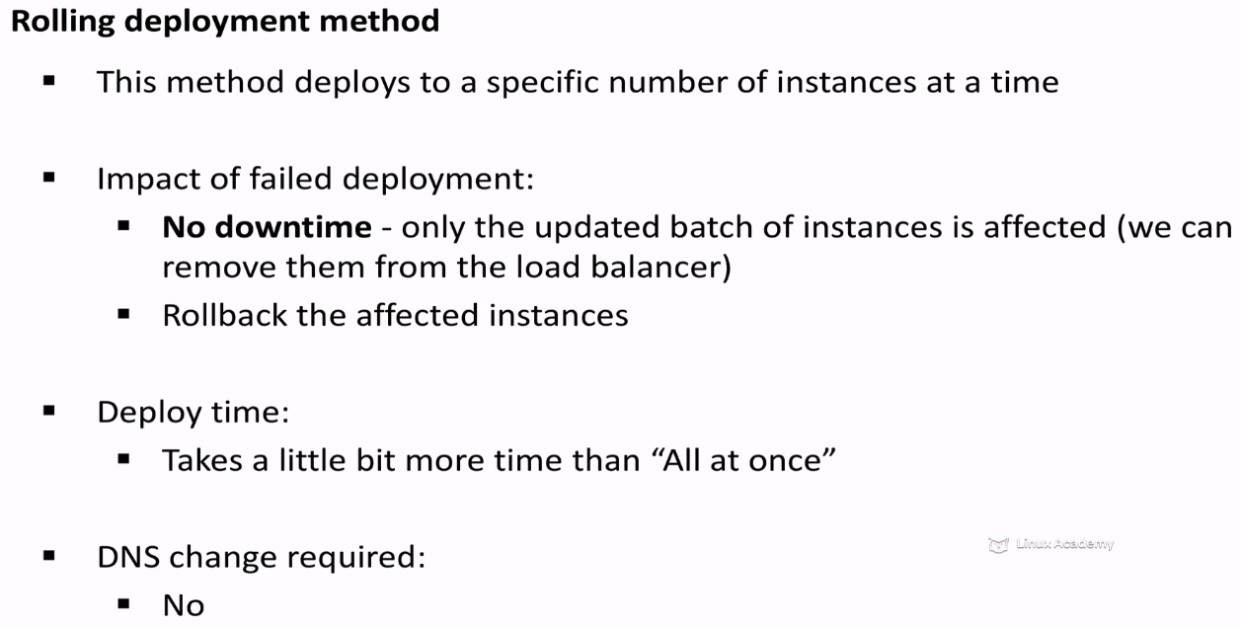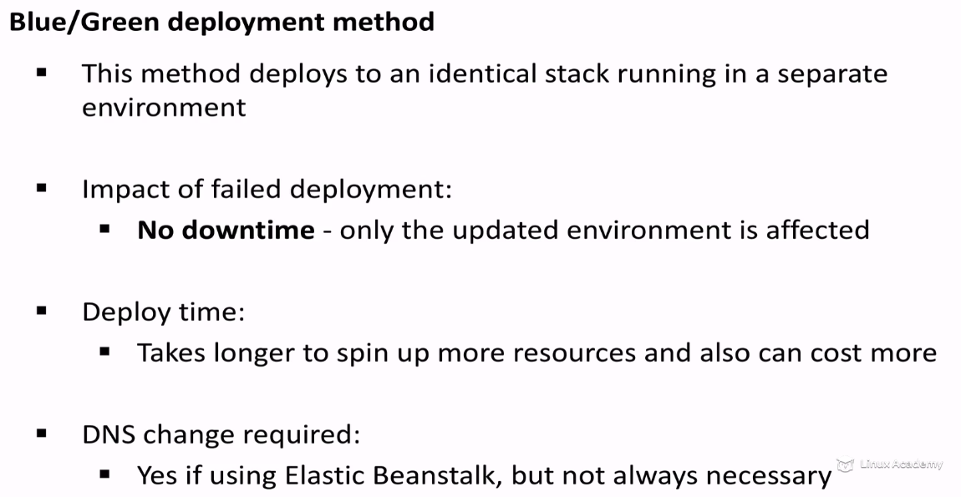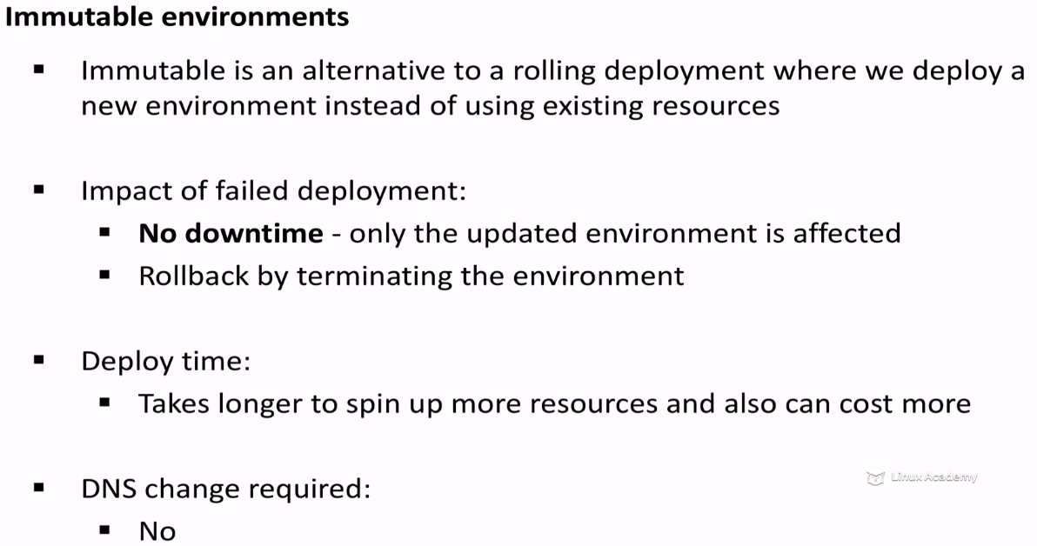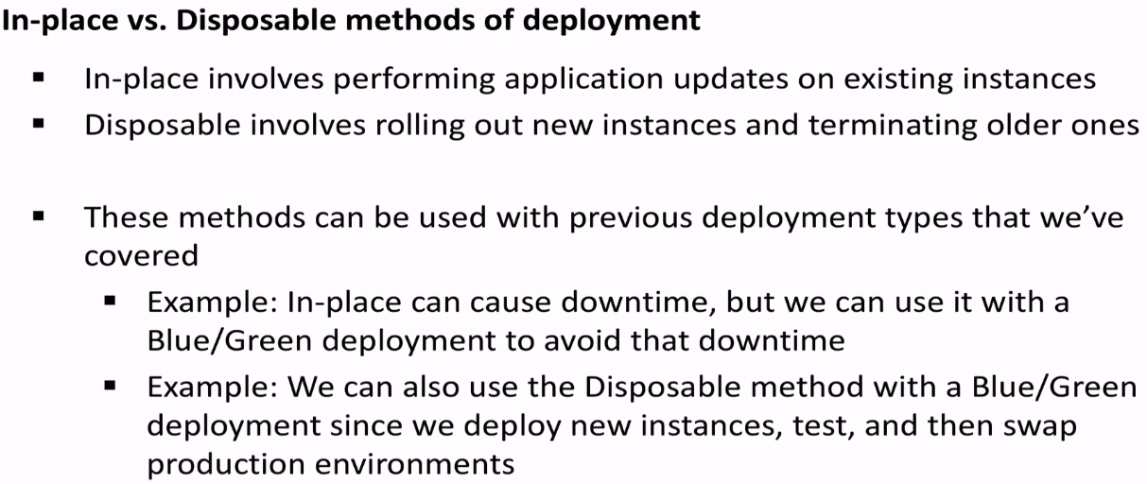 Introduction to Elastic Beanstalk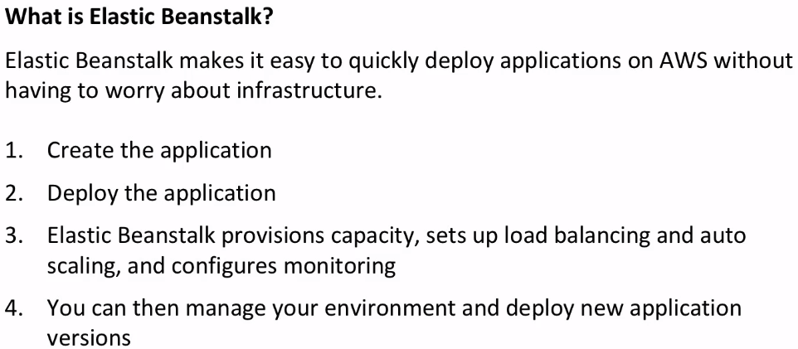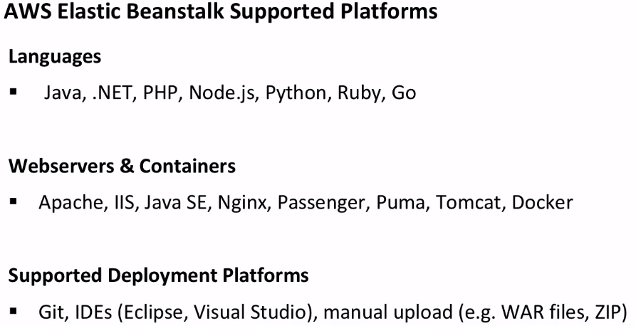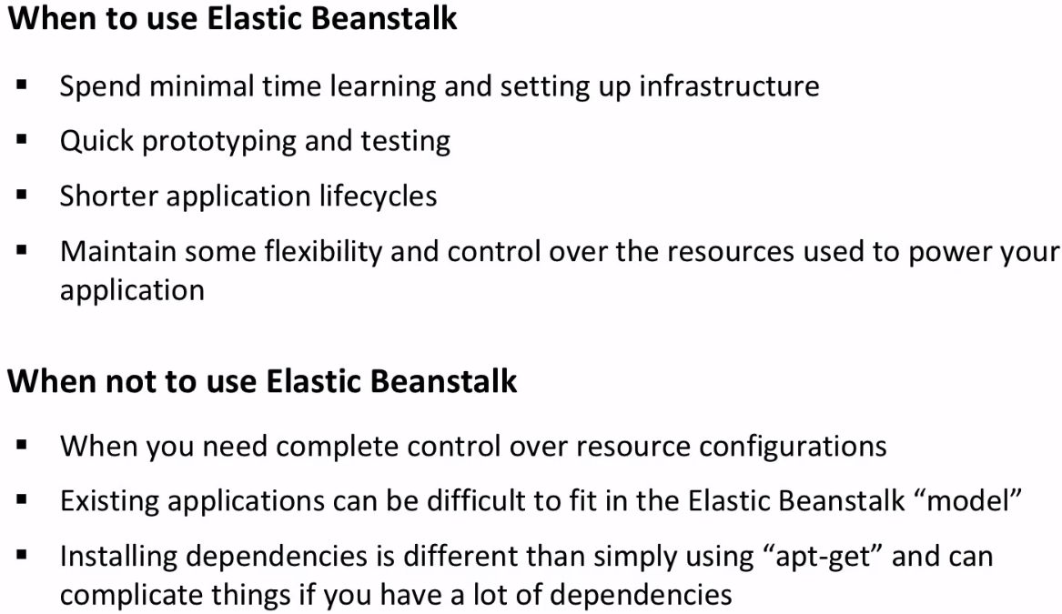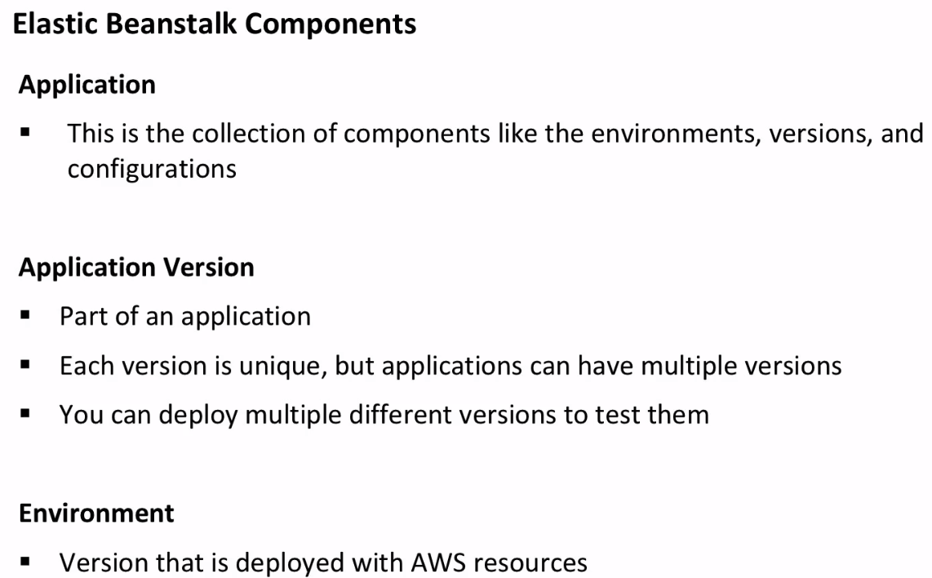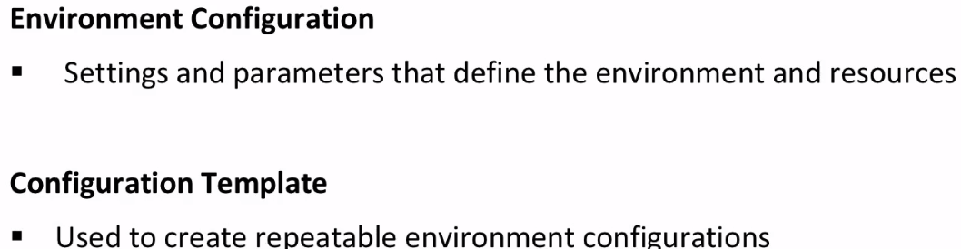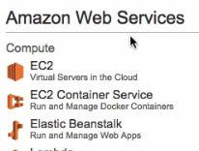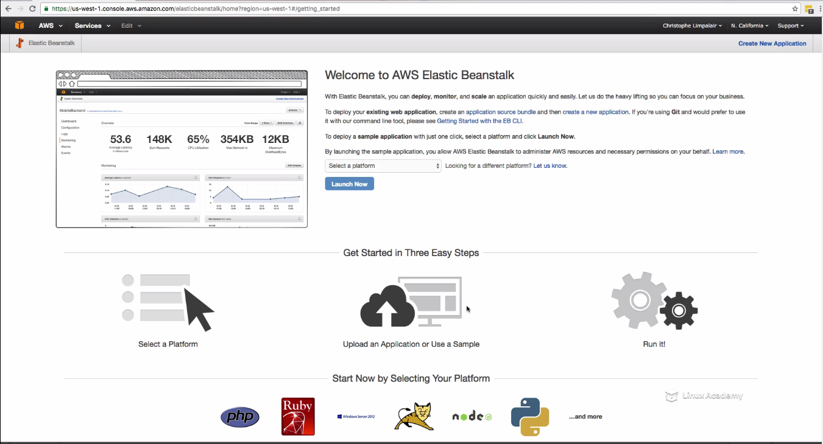

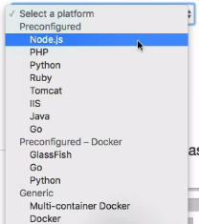

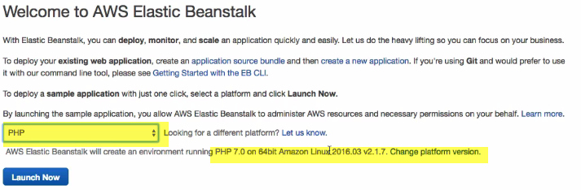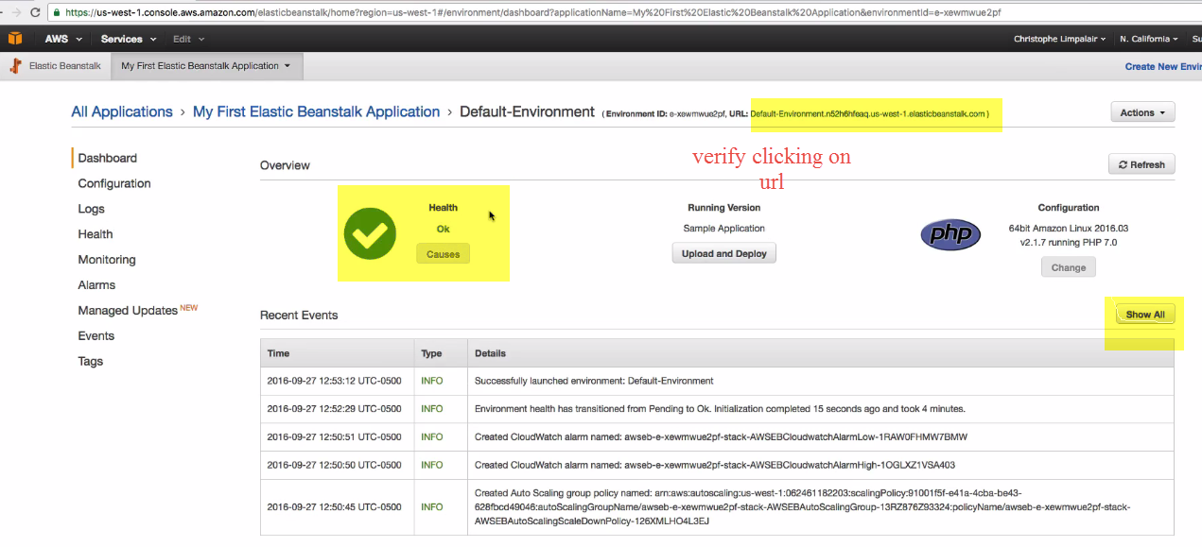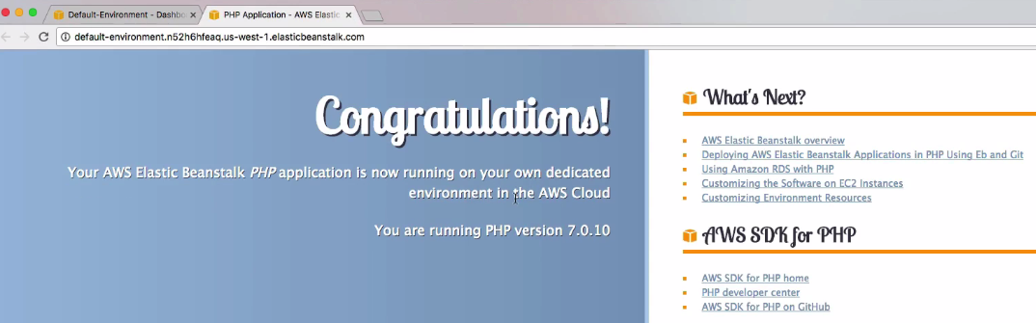

Click Showall-> to know what happened at what time(USING events)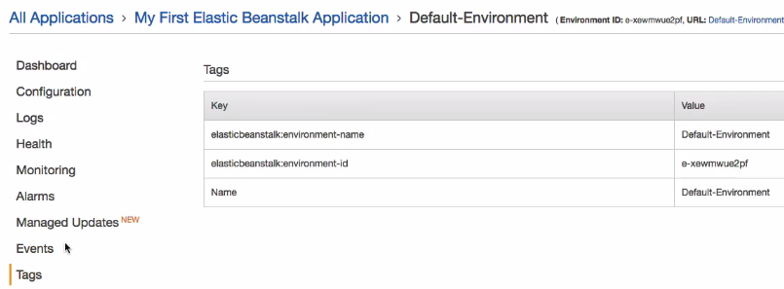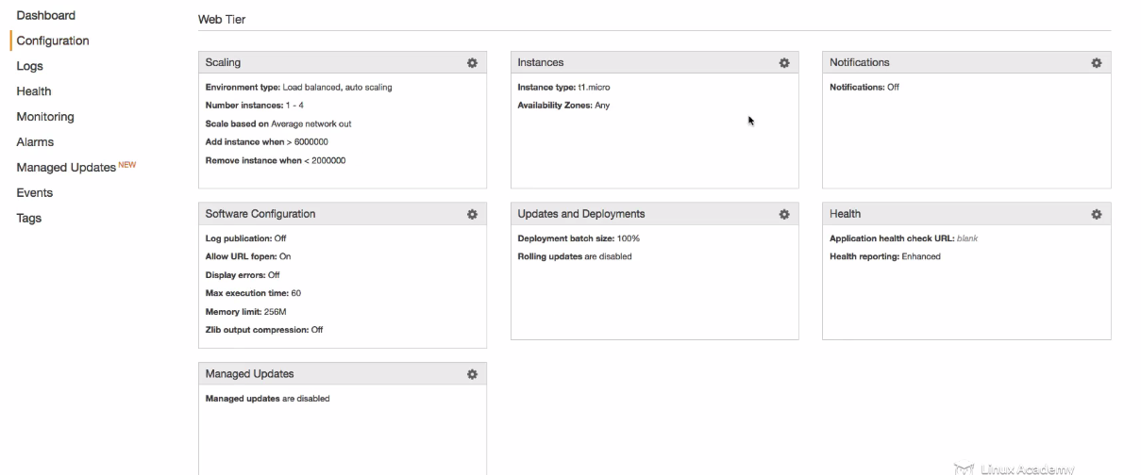 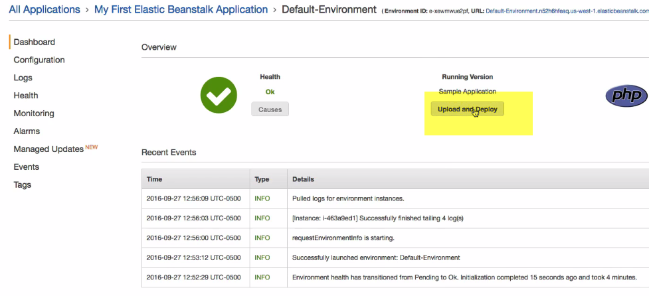

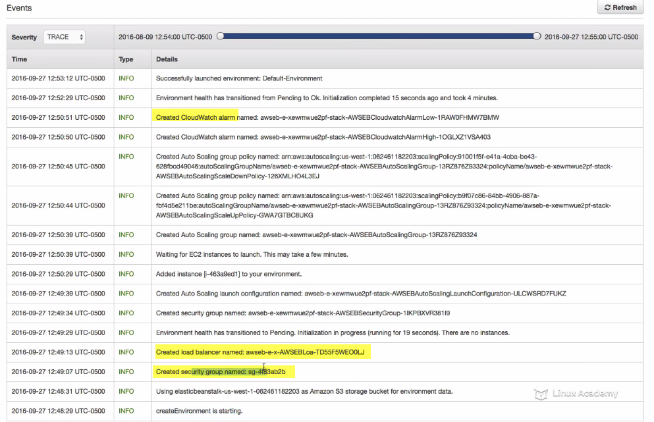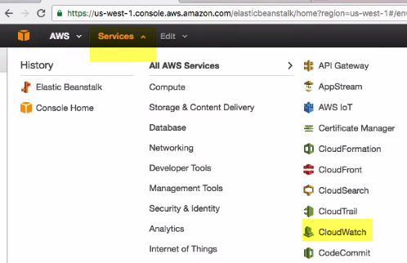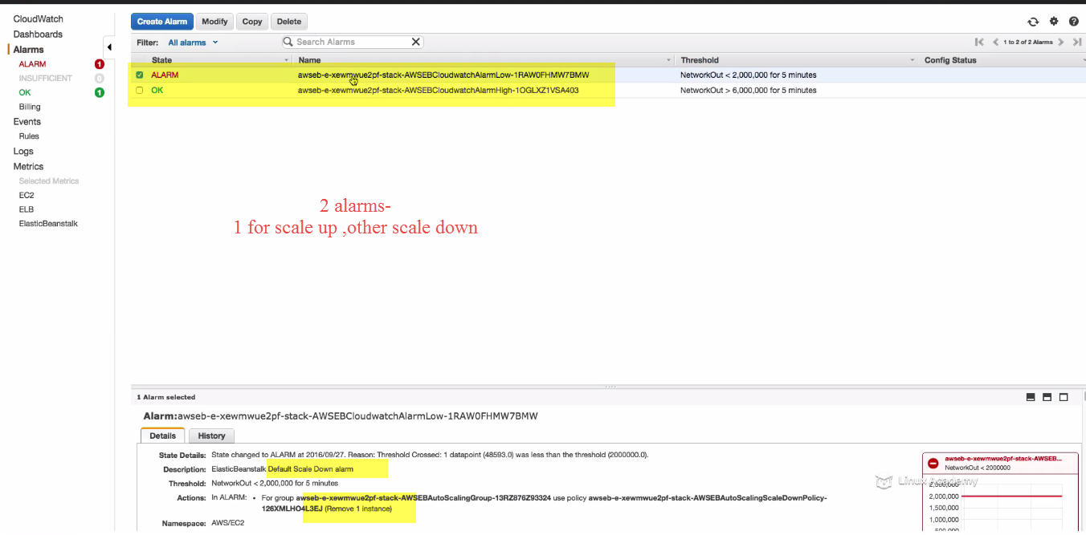

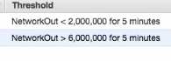

We can see Network threshold<2 🡪 down---instance removed

>6 Up---add instance..

It also does 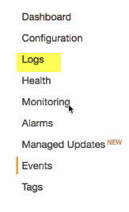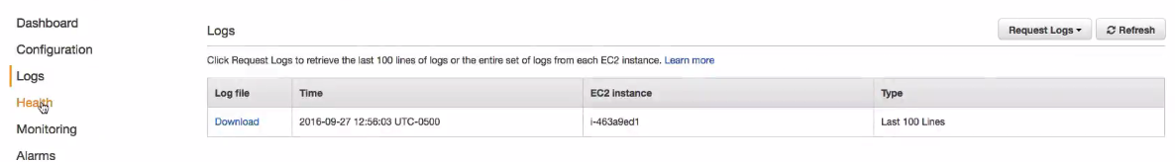

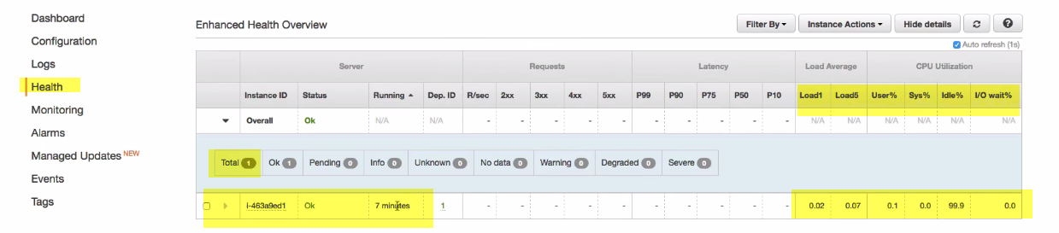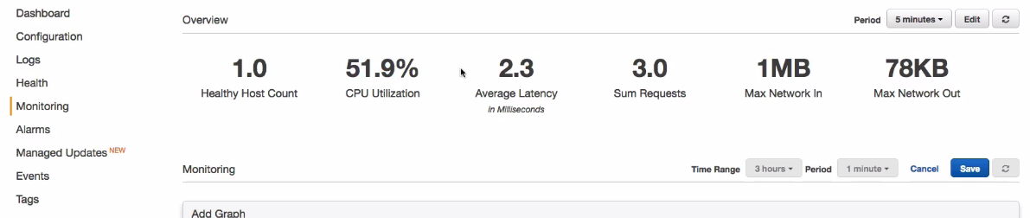 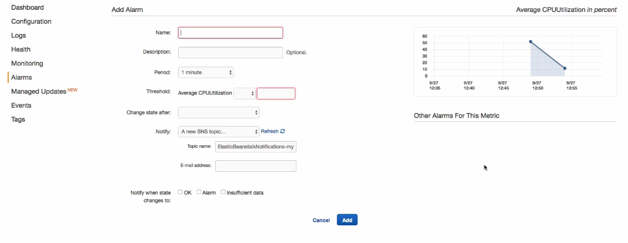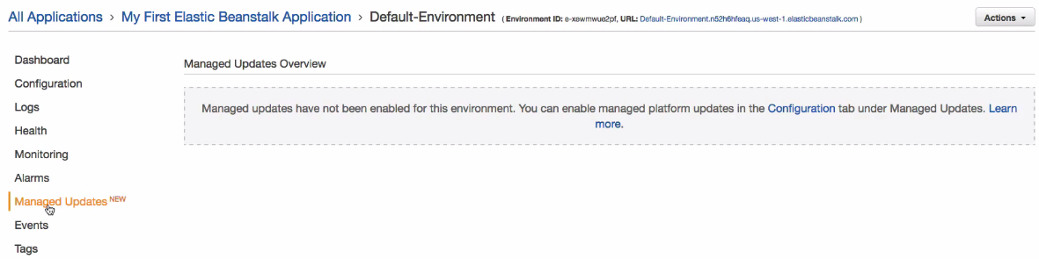

If PHP new version comes or AWS, we can schedule maintenance window to perform updates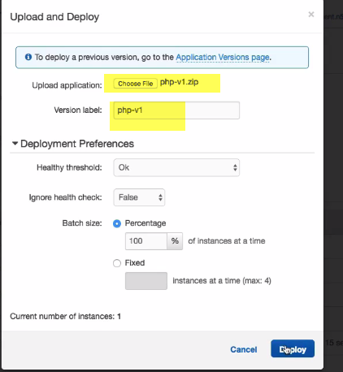

Version is auto-populated based on name of archieve upload.. If we are uploading different versions of same filename, need to change version manually..

So,if we have issue with versions..we can rollback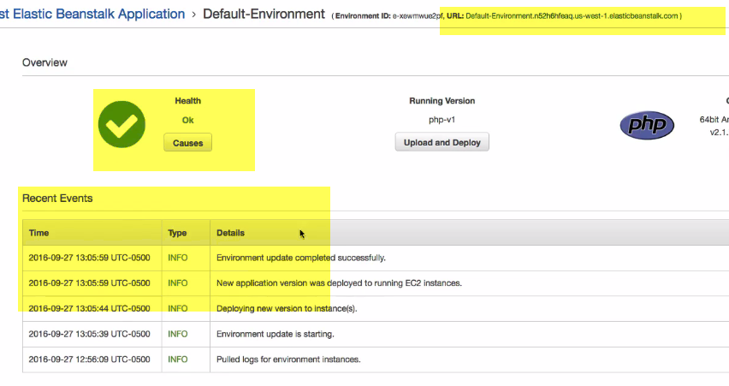

Deployment Health—Ok..Check events

Click URL.. 

35-292-2 - Deployment Strategies Deep Dive with Elastic Beanstalk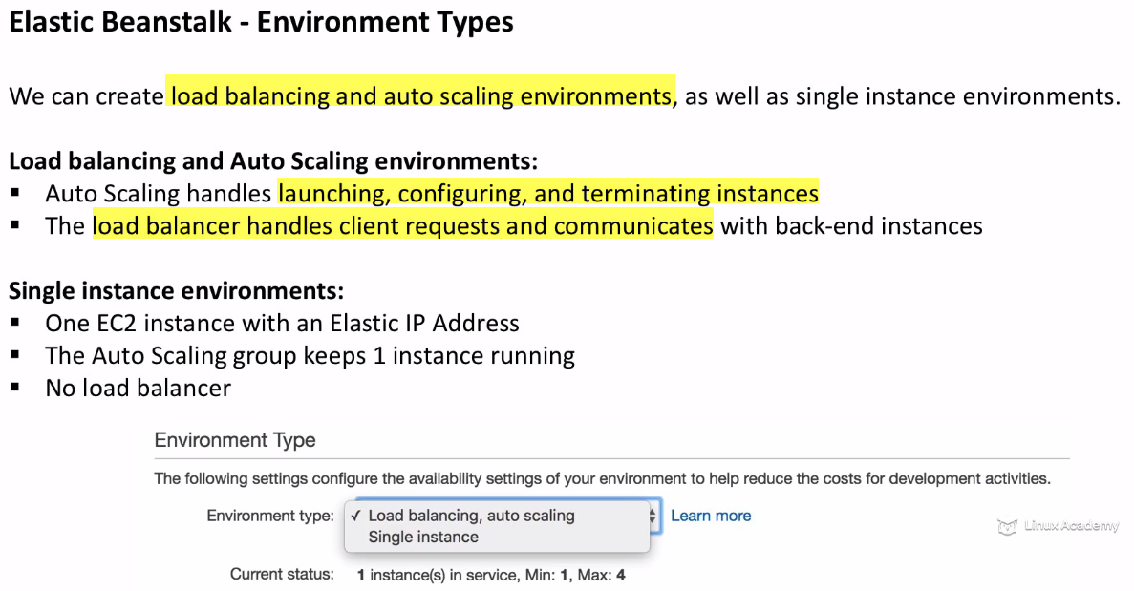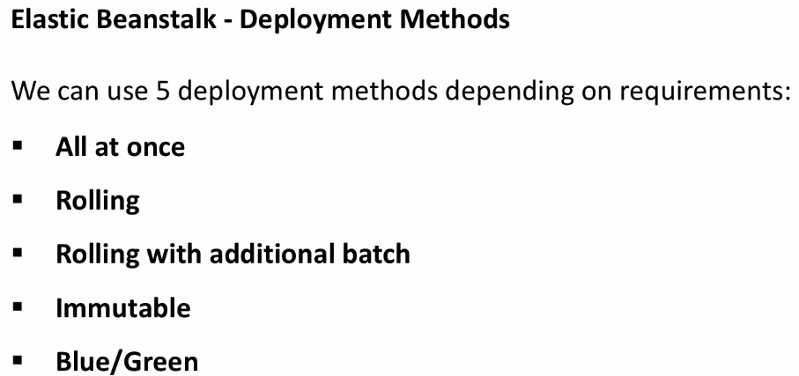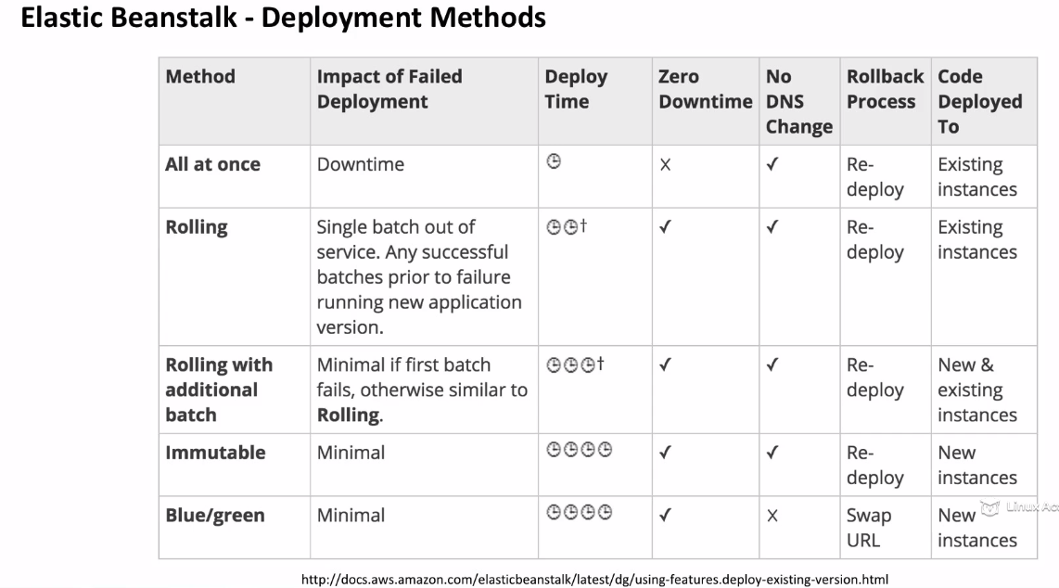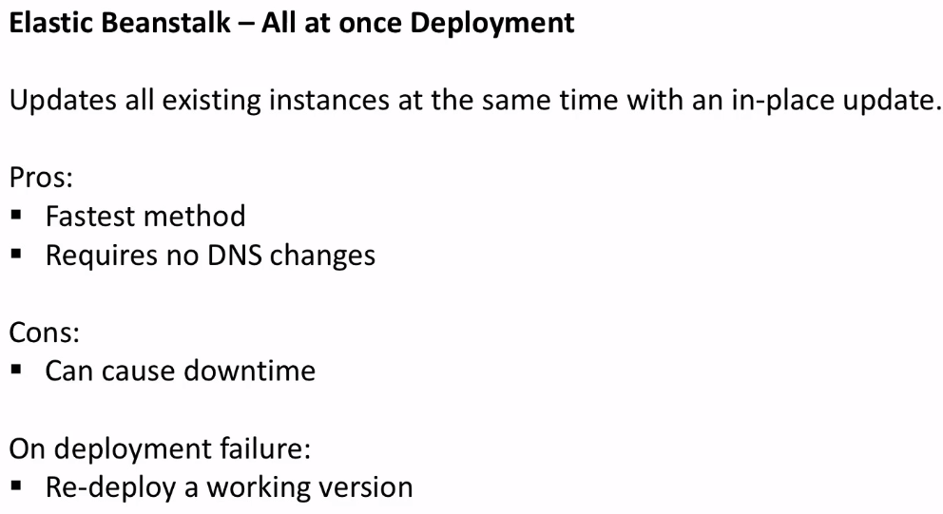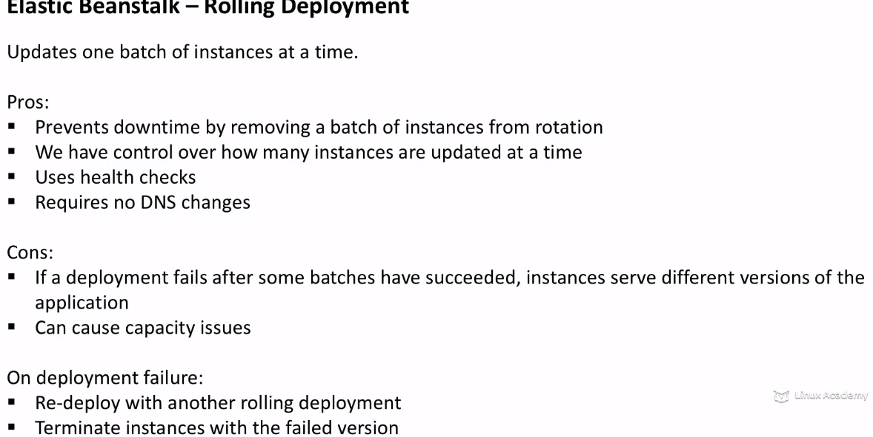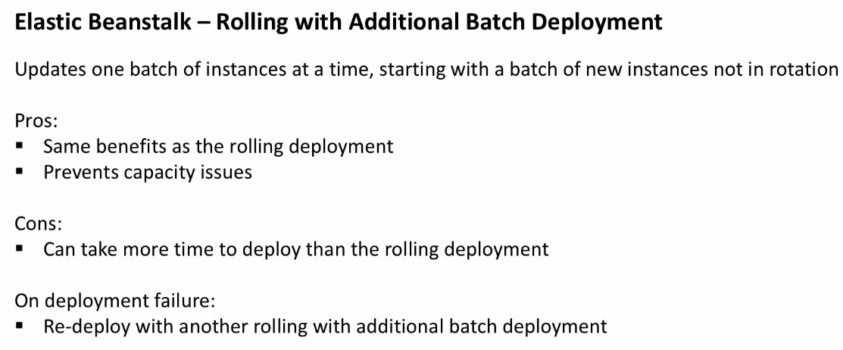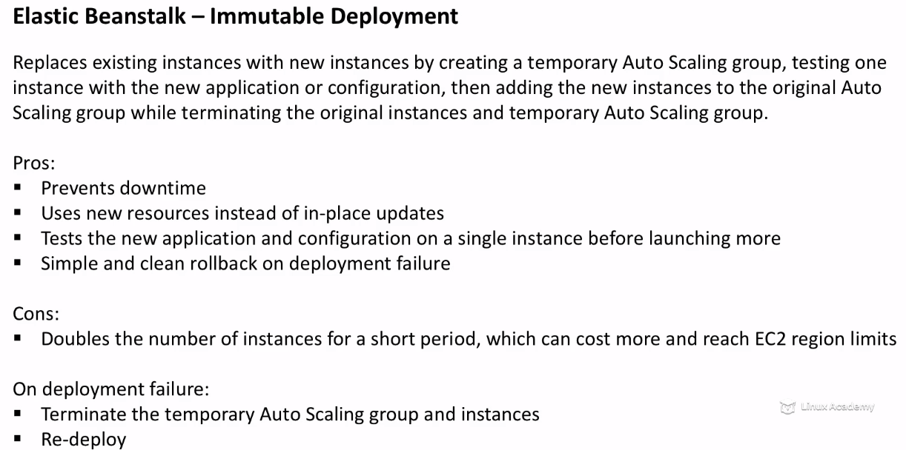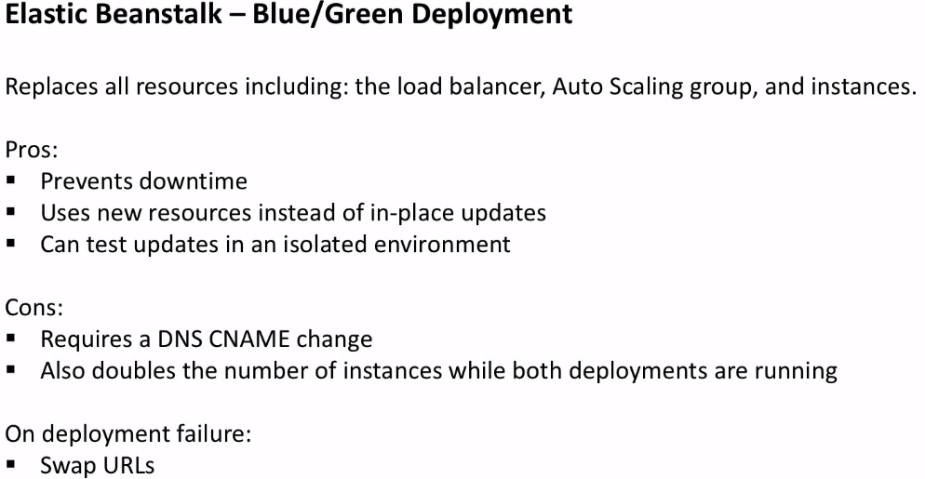Docker Deployments with Elastic Beanstalk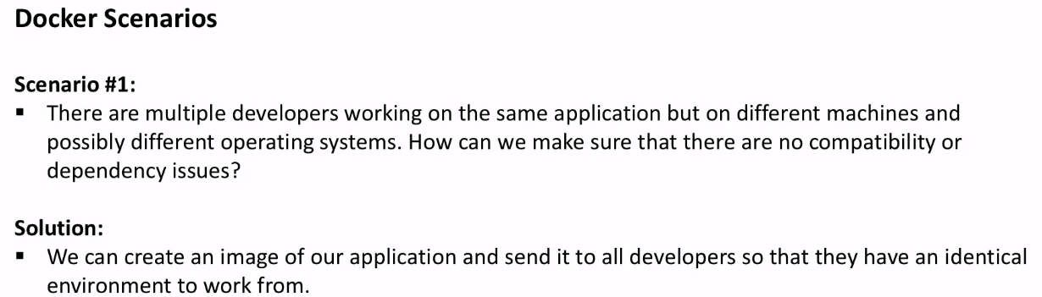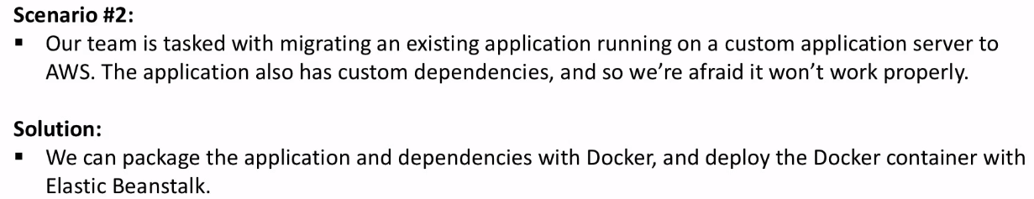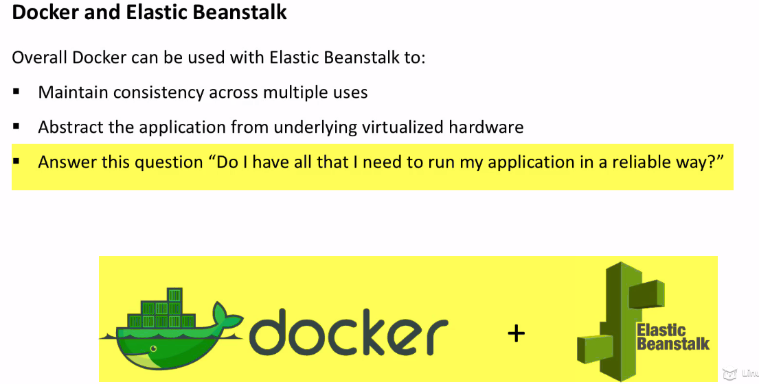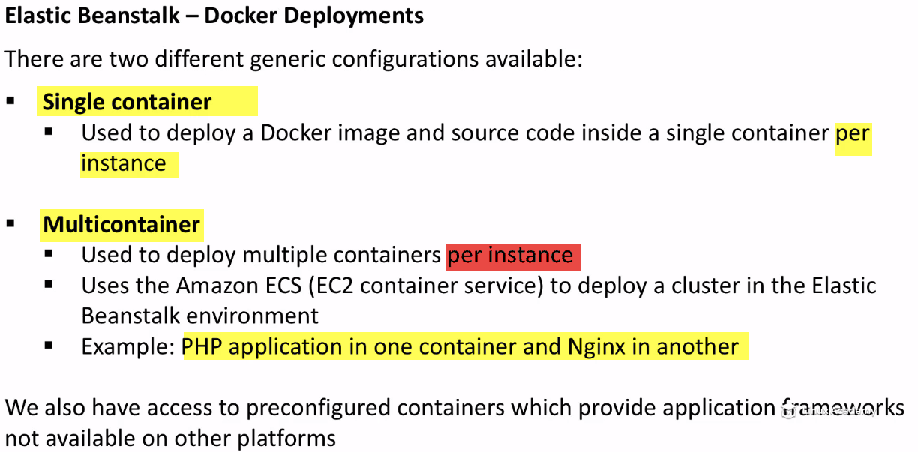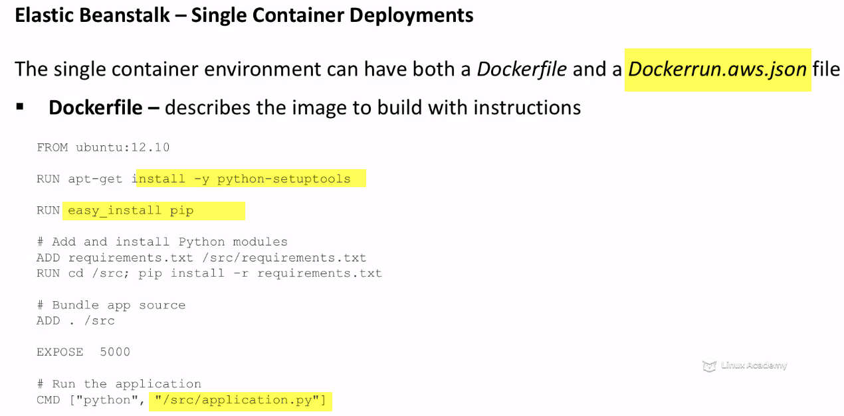

Json file can specify image to use and also EB config..

We can also use both.. Dockerrunfile gives control over EB env.

If we specify image in Dockerfile, we don’t do it it runfile..bevause EB always use image from Dockerfile if it exits

We specify a number of key values in run.json file.. 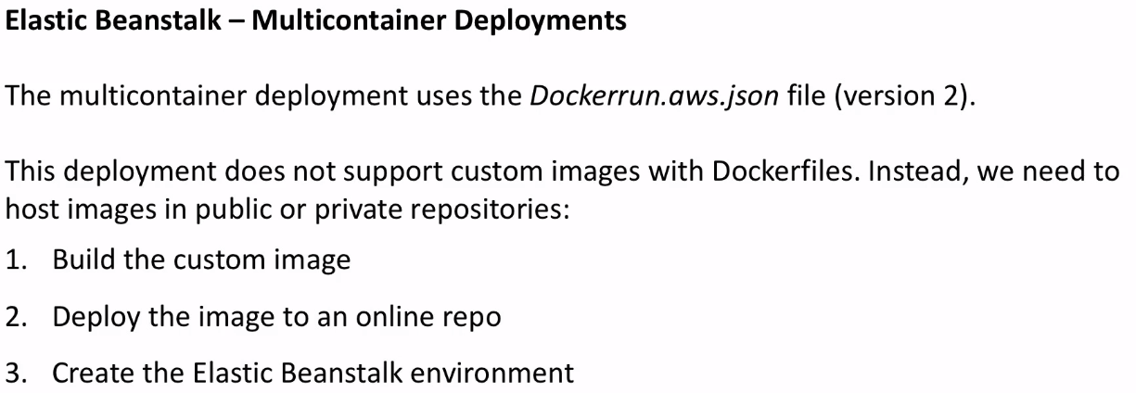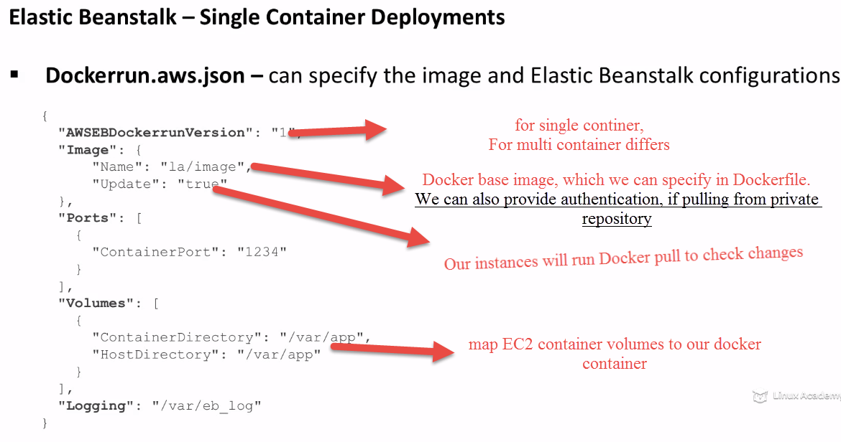

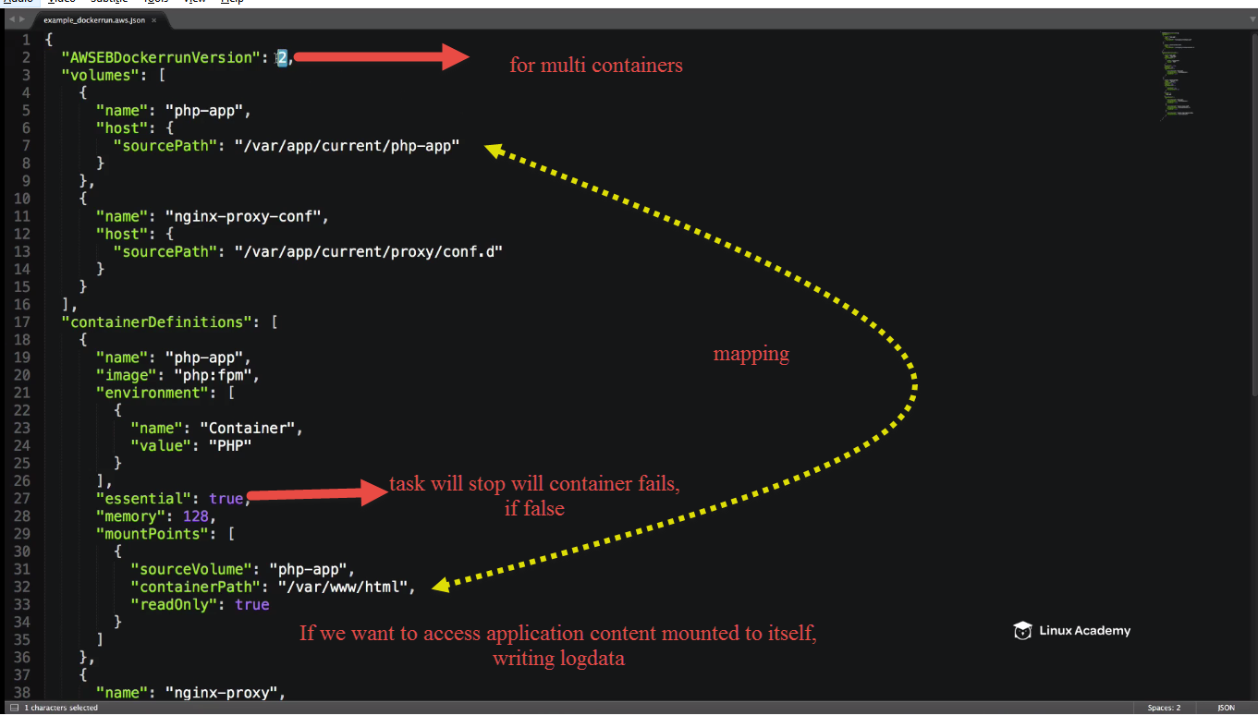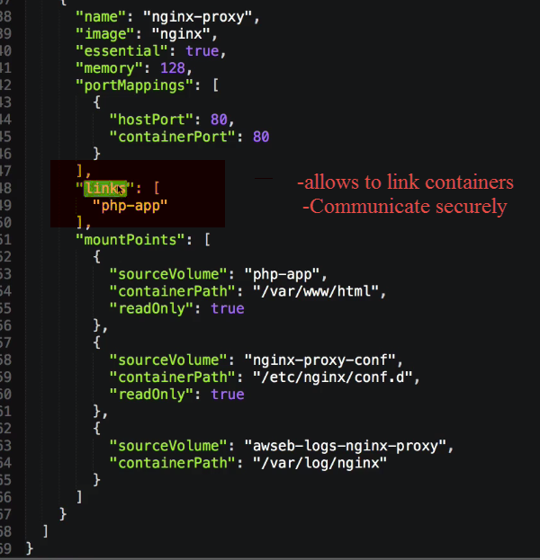

Using PHP and nginx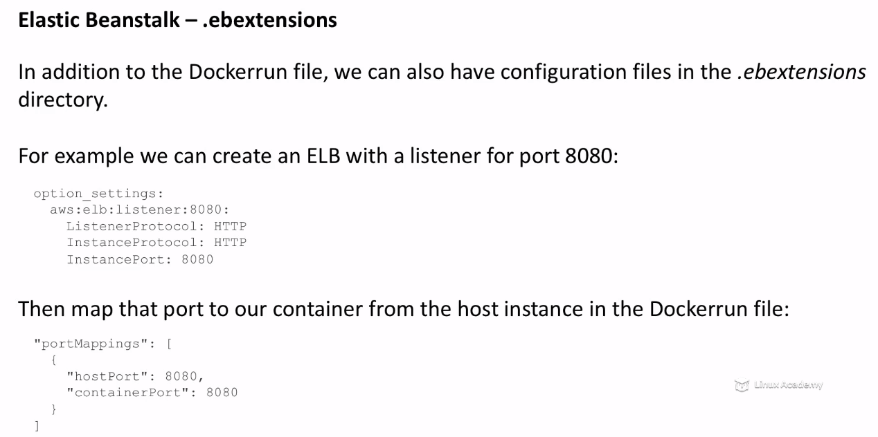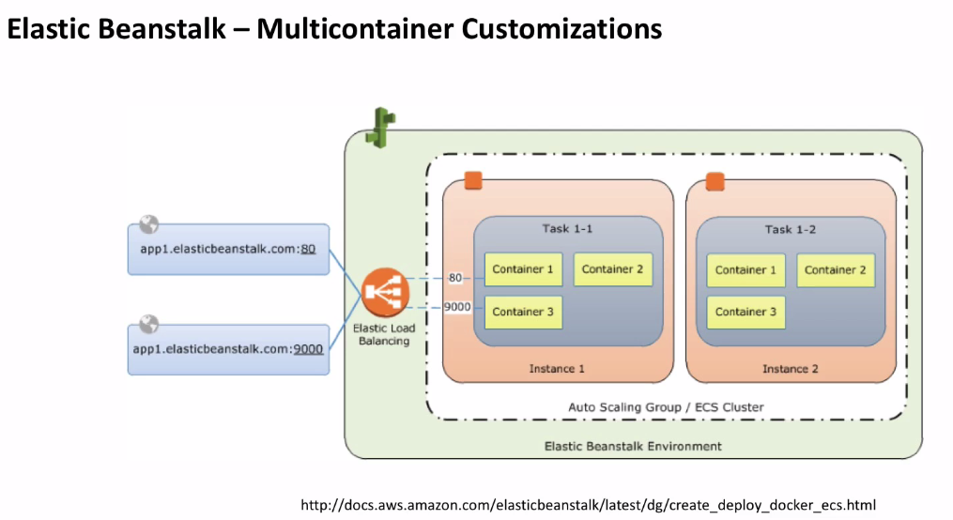35-292-4 - Hands-on_ Single Docker Container Blue_Green Deployments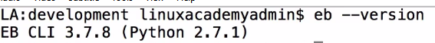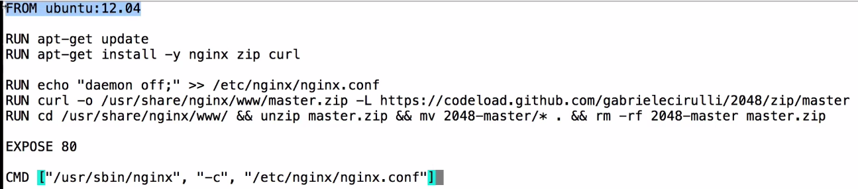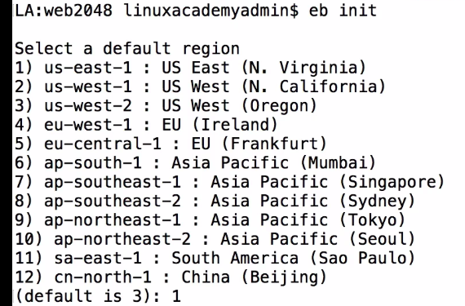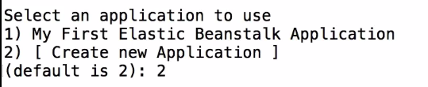

It notices it’s a Docker Application seeing Dockerfile..Select latest Docker version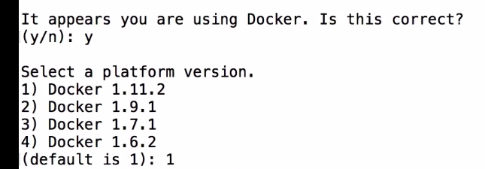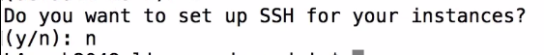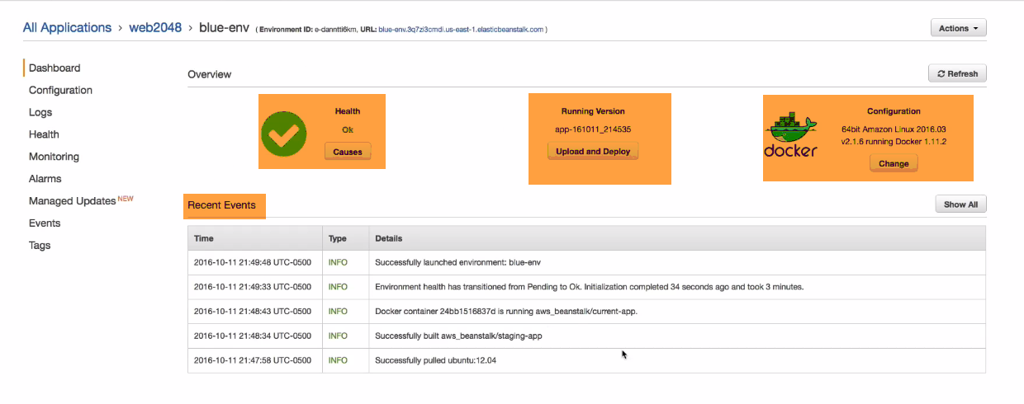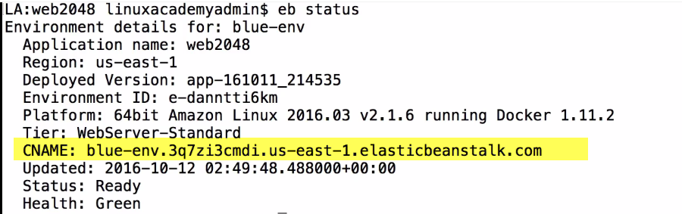Use cname on browser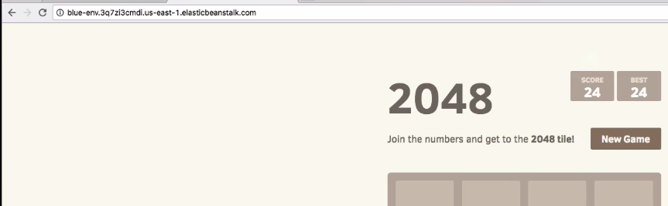

**Now Blue-Green Deployments:**

1. Change application so that wer can see diff.
2. Create new EB env. For updated code.
3. Swap to perform blue-green deployment..

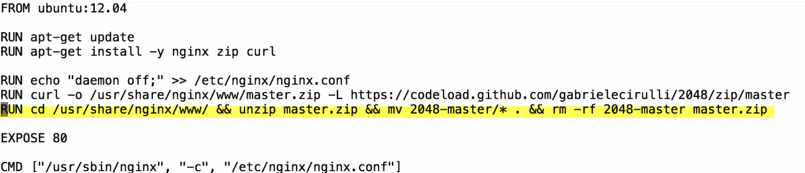

Delete this crucial line from Dockerfile

Packaging Dockerfile.

If any code, it uploads to amazon S3..EB download from S3and deploy APP in Docker container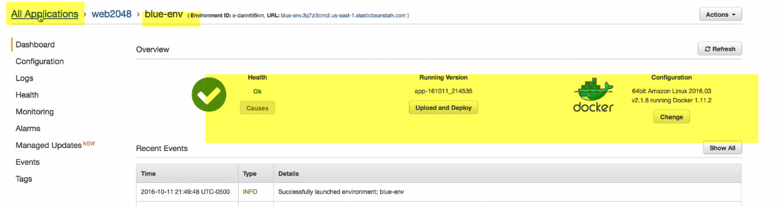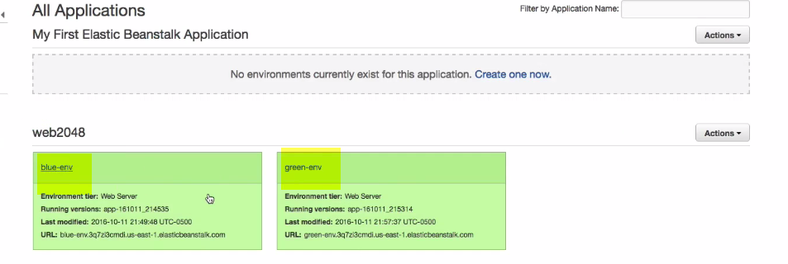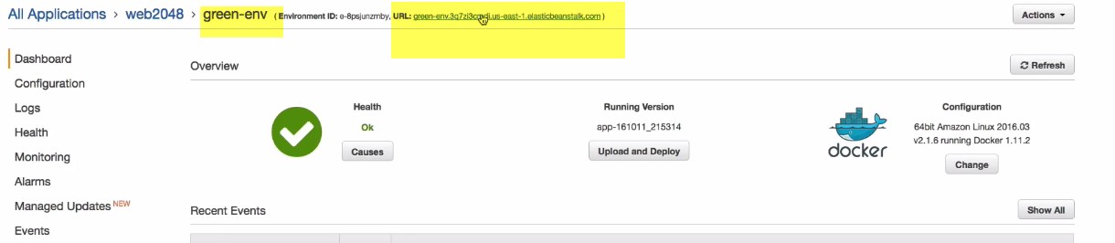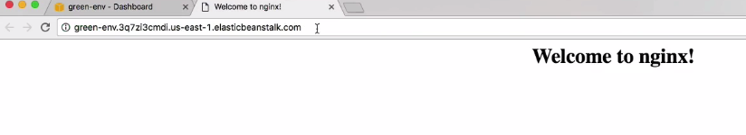

Application is never deployed here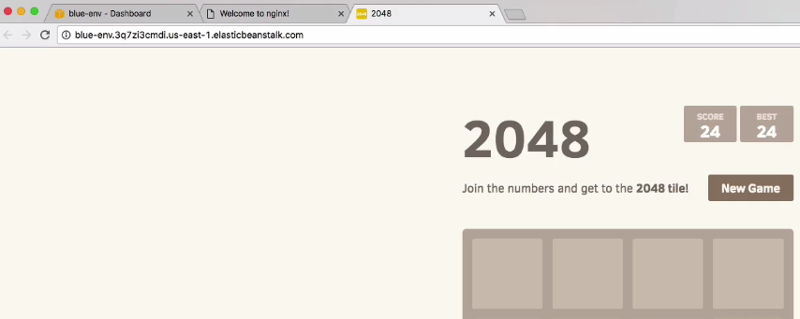

2048(Blue-old)-🡪 Prod Environment

Nginx(green---new)🡪 Dev, QA, Stage(lower env)

This is approved to move to PROD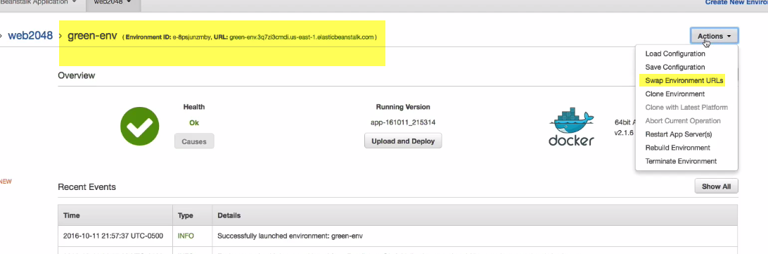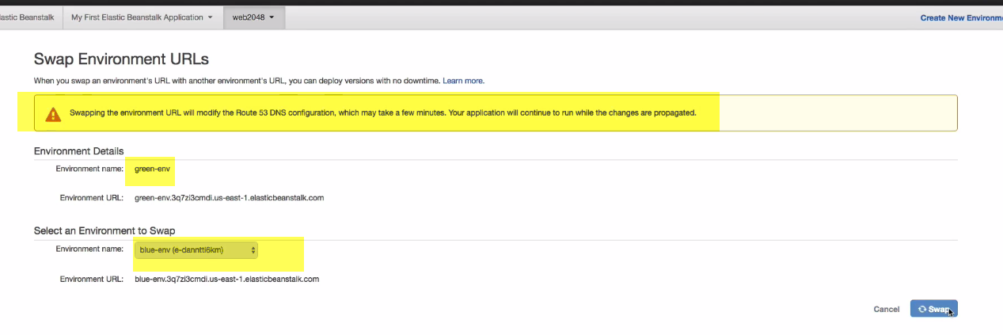

This will change URl of green into Blue

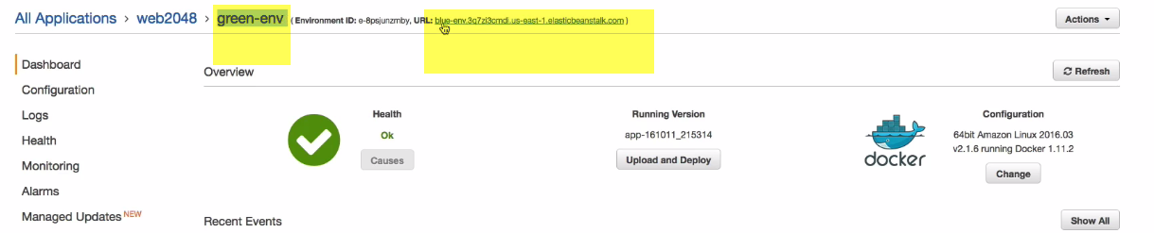

IN Green Env. We actually have URL. Of Blue env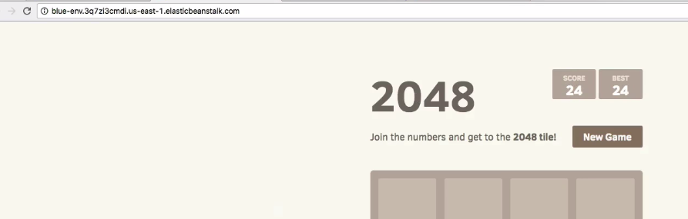

ON Prod(blue env)

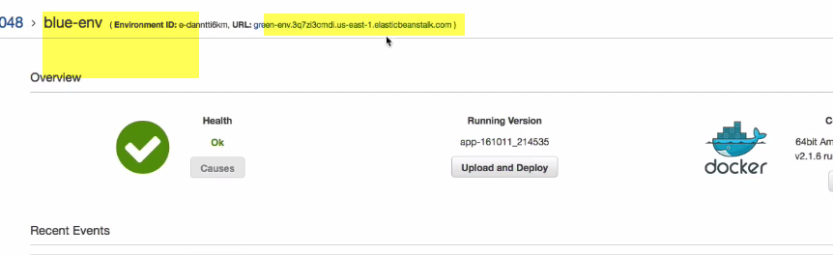

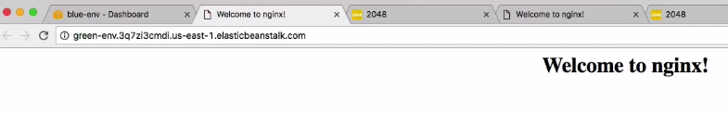

This is bad version..Developers have seen there is problem

**ROllback**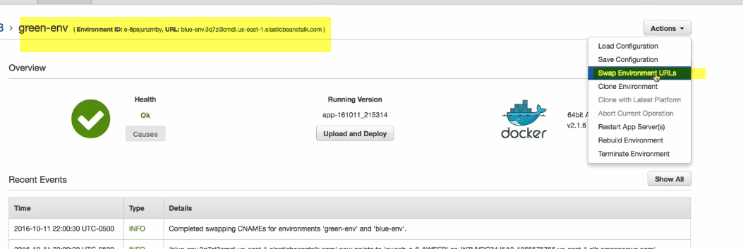

**Goto green env.(swap url)** 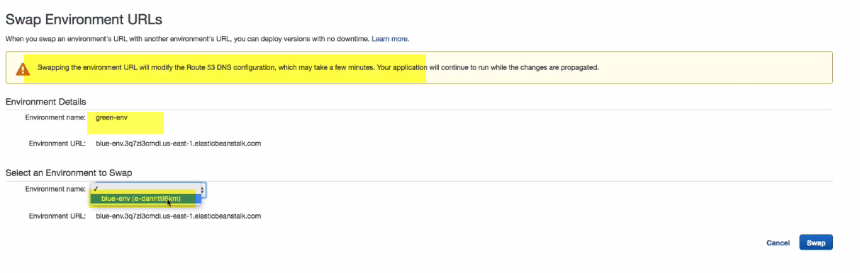

We will swap.. This will revert back, what we have originally.

Now green have 🡪nginx(faulty) not open to public

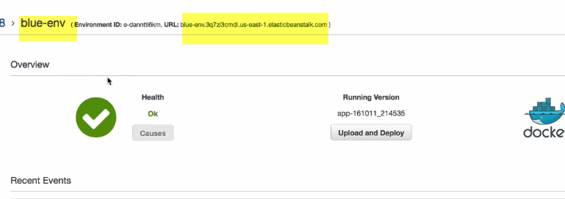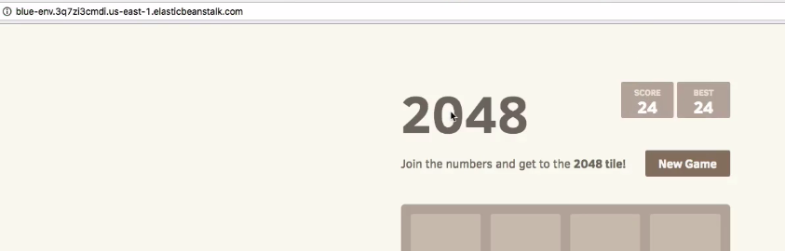

**We have successfully deployed faulty version and rollback..**

5-292-5 - Environment Configurations

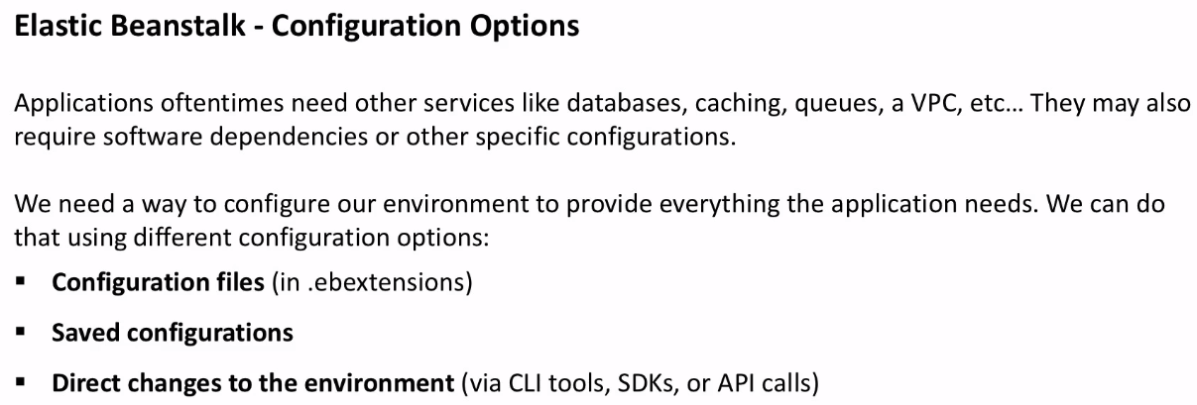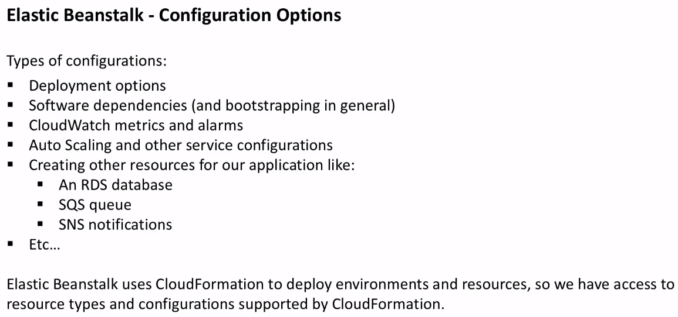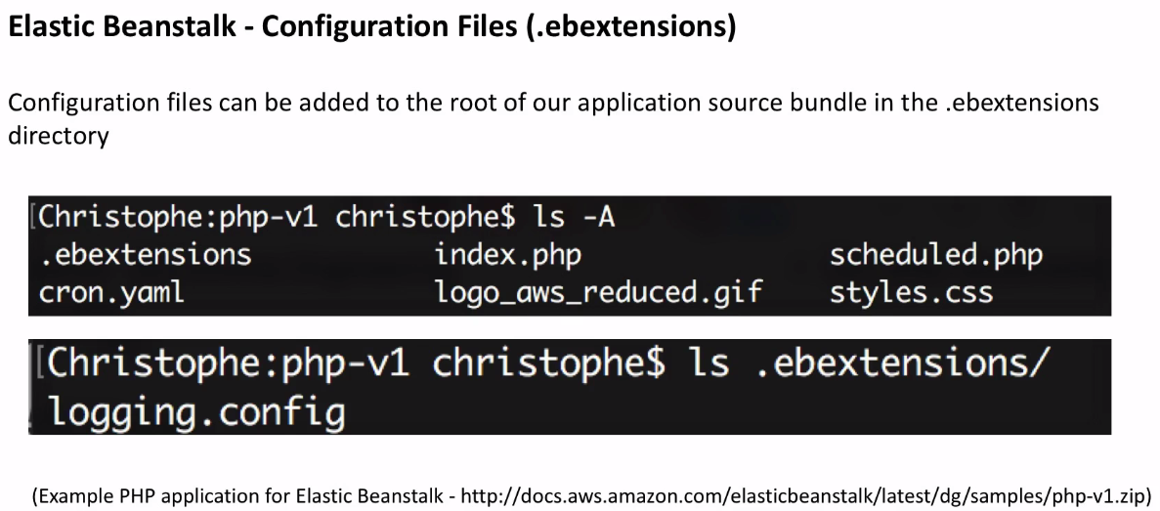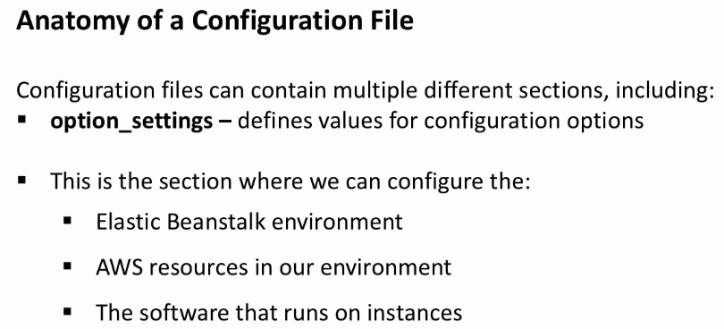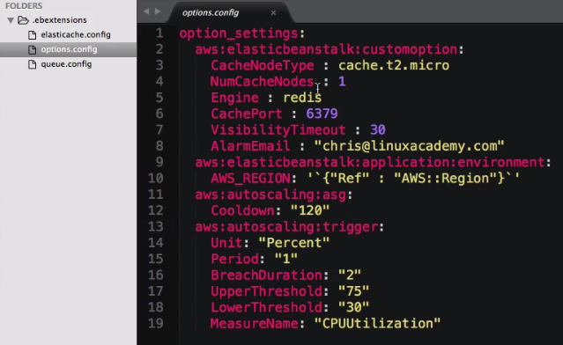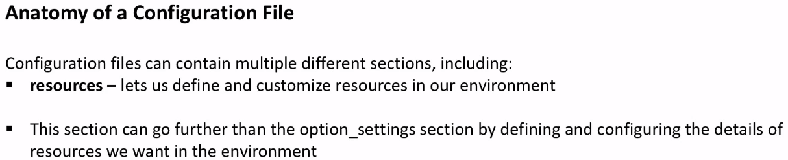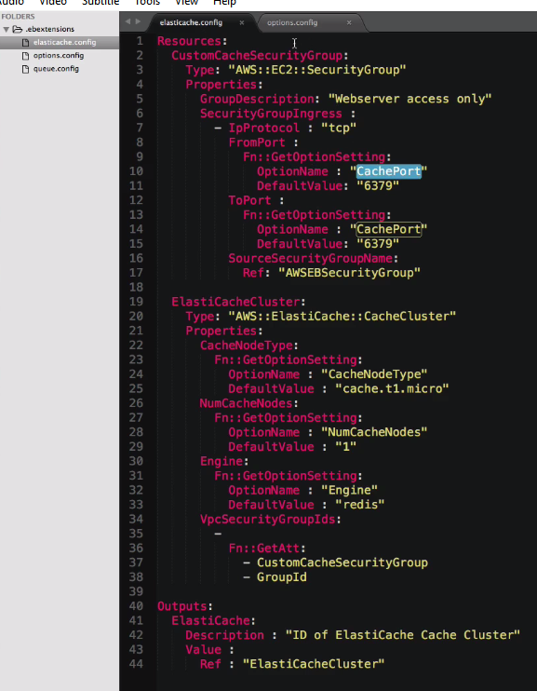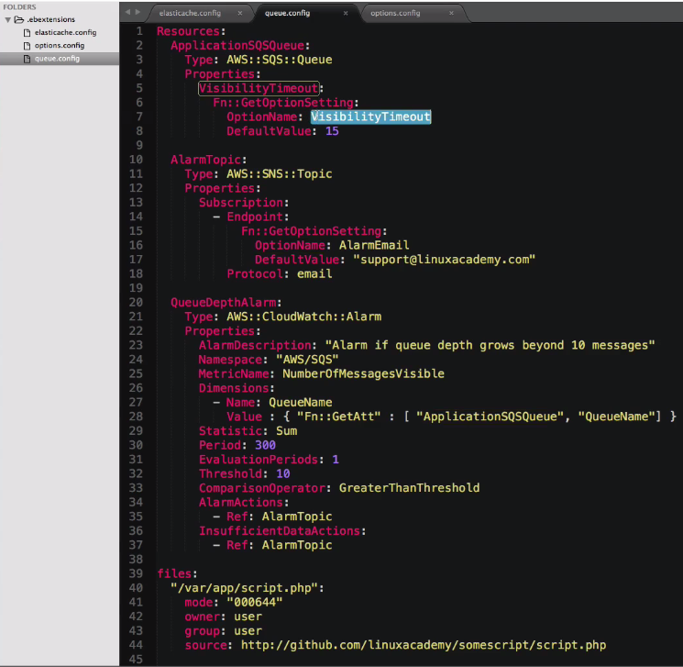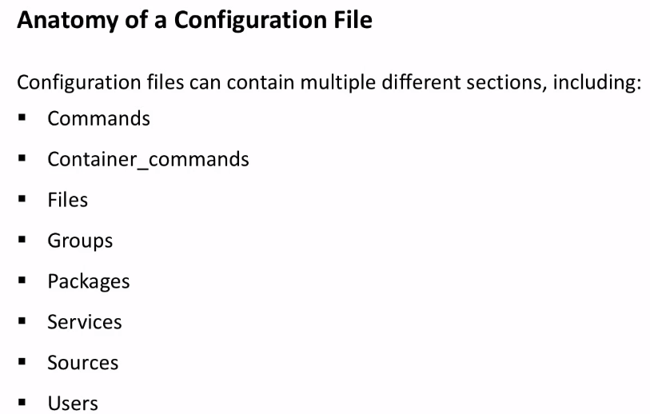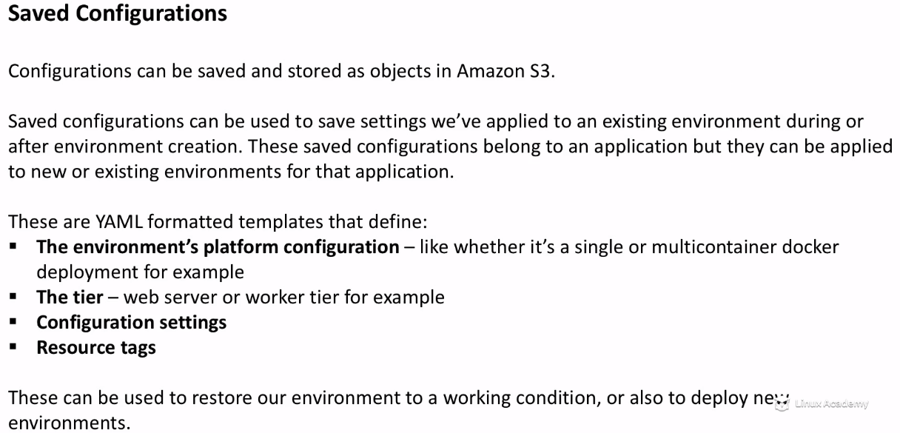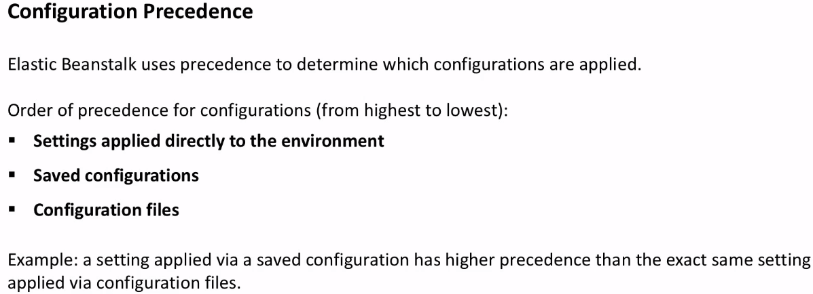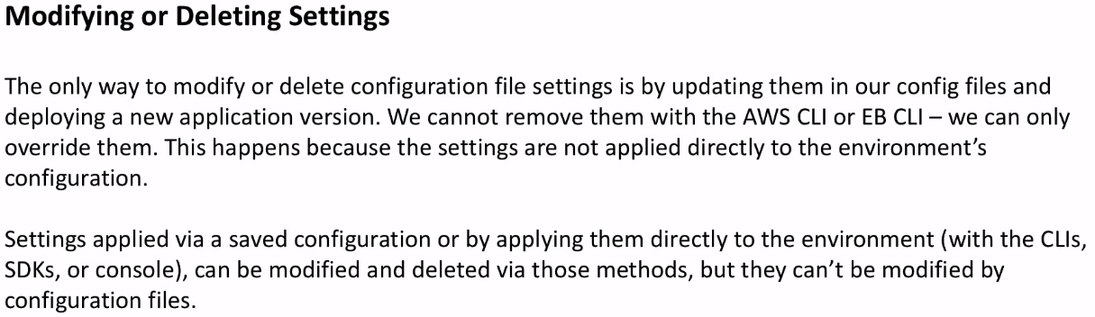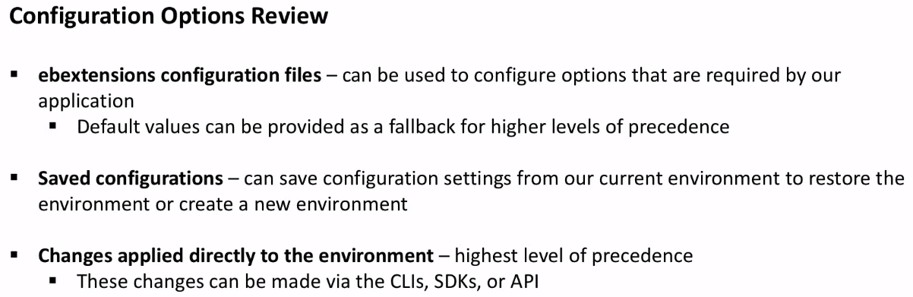35-292-6 - Elastic Beanstalk Scenarios

Check from Video..